- Write program demonstrates how to use regular expressions in Python to match and search for patterns in text.
A. import re
text = input("Enter a text: ")
pattern = input("Enter the pattern to search: ")
match = re.search(pattern, text)
if match:
print("Pattern found!")
print("Matched Text:", match.group())
print("Starting Position:", match.start())
else:
print("Pattern not found.")

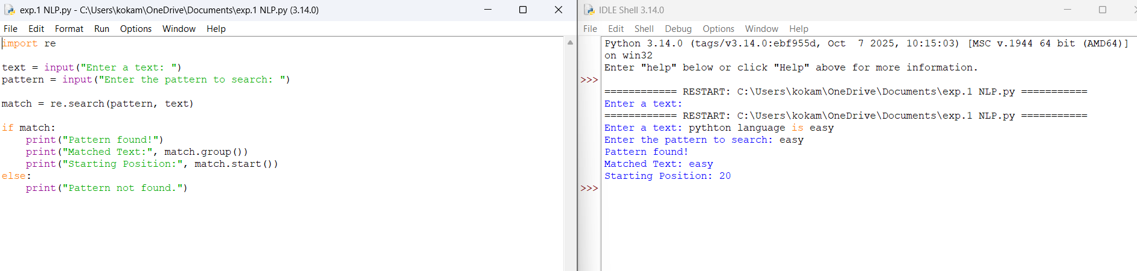
OUTPUT:

- Implement a basic finite state automaton that recognizes a specific language or pattern. In this example, we'll create a simple automaton to match strings ending with 'ab' using python.
A . # Finite State Automaton to recognize strings ending with "ab"
string = input("Enter a string: ")
if string.endswith("ab"):
print("String Accepted")
else:
print("String Rejected")
OUTPUT ;
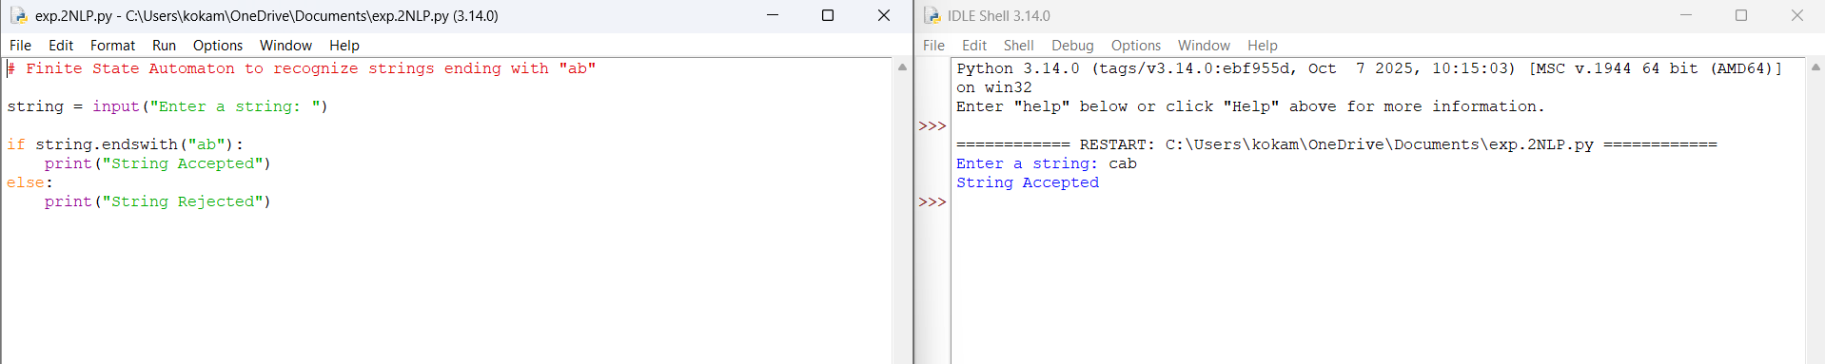
- Write program demonstrates how to perform morphological analysis using the NLTK library in Python.
A. from nltk.stem import PorterStemmer
ps = PorterStemmer()
words = ["playing", "running", "studies", "happily"]
for word in words:
print(word, "->", ps.stem(word))
OUTPUT;
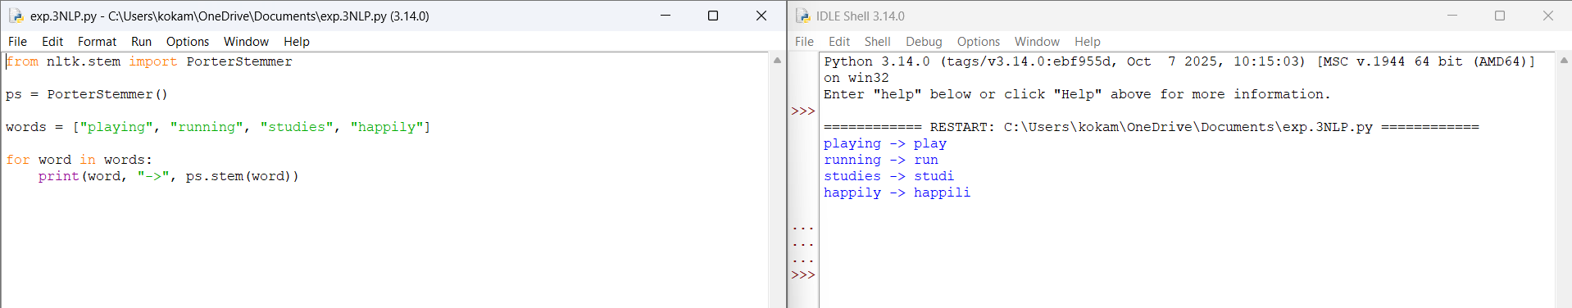
- mplement a finite-state machine for morphological parsing. In this example, we'll create a simple machine to generate plural forms of English nouns using python.
A. noun = input("Enter a noun: ")
if noun.endswith("y"):
plural = noun[:-1] + "ies"
else:
plural = noun + "s"

print("Plural Form:", plural)
OUTPUT;
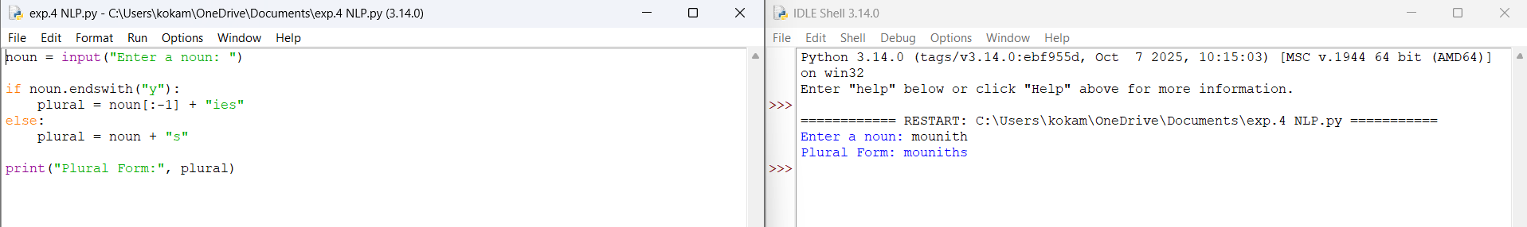
- Use the Porter Stemmer algorithm to perform word stemming on a list of words using python libraries.
A. from nltk.stem import PorterStemmer
stemmer = PorterStemmer()
words = ["connected", "connecting", "connection", "connections"]
for word in words:
print(stemmer.stem(word))
OUPUT;
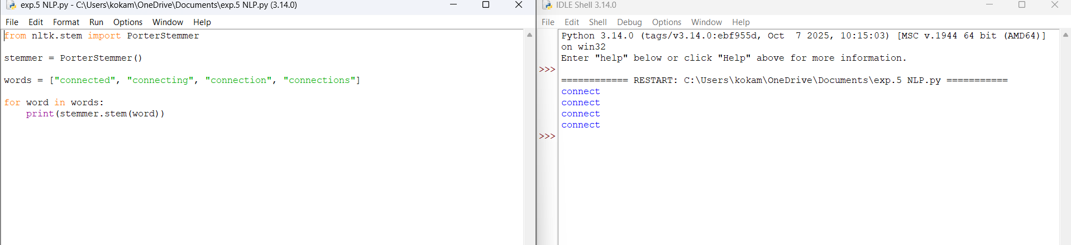
- Implement a basic N-gram model for text generation. For example, generate text using a bigram model using python.
A. from nltk import bigrams
text = "I love natural language processing"
words = text.split()
for bg in bigrams(words):
print(bg)
OUTPUT;
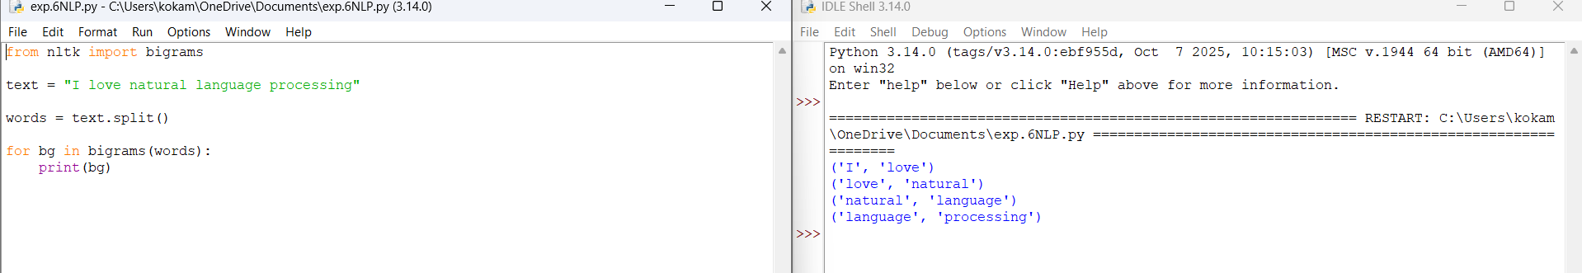
- To perform POS tagging using NLTK.
A.
import nltk
sentence = "The boy is playing football"
tokens = nltk.word_tokenize(sentence)
print(nltk.pos_tag(tokens))
OUTPUT ;

